

RAJIV GANDHI COLLEGE OF ENGINEERING AND TECHNOLOGY

DEPARTMENT OF COMPUTER SCIENCE AND ENGINEERING

COMPUTER NETWORKS LABORATORY (CS P52)

B. Tech – V SEMESTER

STUDENT NAME: SURESH S
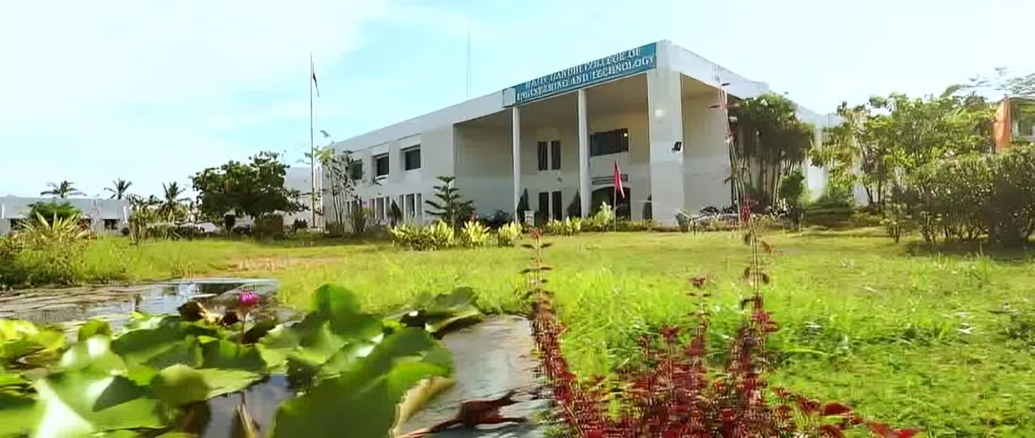
REGISTER NO : 22TD0091

(Approved by AICTE and Affiliated to Pondicherry University)

ISO 9001:2015

PUDUCHERRY – 607 403
OCTOBER 2024

RAJIV GANDHI COLLEGE OF ENGINEERING
AND TECHNOLOGY
(Approved by AICTE and Affiliated to Pondicherry University)
ISO 9001:2015
Pondy – Cuddalore Main Road, Kirumampakkam, Puducherry - 607403

DEPARTMENT OF COMPUTER SCIENCE
AND ENGINEERING



Record Note Book

Name : SURESH S
Register No. : 22TD0091
Course : B. Tech (CSE)
Year / Semester : Y3/ S5
Subject & Code : COMPUTER NETWORKS LABORATORY (CS P52)

RAJIV GANDHI COLLEGE OF ENGINEERING
AND TECHNOLOGY
(Approved by AICTE and Affiliated to Pondicherry University)
ISO 9001:2015

Pondy – Cuddalore Main Road, Kirumampakkam, Puducherry – 607 403.



DEPARTMENT OF COMPUTER SCIENCE AND ENGINEERING

BONAFIDE CERTIFICATE

This is to certify that the bonafide record of practical work done by Mr. SURESH S, Reg.No.22TD0091 pursuing Third year B.Tech of Department of Computer Science and Engineering in COMPUTER NETWORKS LABORATORY (CSP52) during the University Exam October 2024.
Faculty In-charge | Head of the Department
Submitted for the University Examination held on _________________

Internal Examiner External Examiner

DEPARTMENT OF COMPUTER SCIENCE AND
ENGINEERING

COMPUTER NETWORKS LABORATORY (CS P52)

B. Tech – V SEMESTER

STUDENT NAME: SURESH S
REGISTER NO: 22TD0091



RAJIV GANDHI COLLEGE OF ENGINEERING AND
TECHNOLOGY

(Approved by AICTE and Affiliated to Pondicherry University)
ISO 9001:2015

PUDUCHERRY- 607 403
OCTOBER 2024

